**Title**: Math Circles

**Subject**: Math

**Grade level**:  Cycle 3 (can be adapted for younger grades)

**Objectives**: Helps student practice their place values.

**Materials**: Instruction cards and labels with numbers 0-10 (make enough for each student, numbers may be repeated)

**EXAMPLE**:

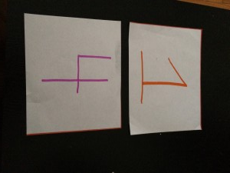 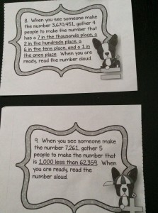

**Brief Description:**  This activity is great to do outdoors. It should take approximately 20 min. Start by handing out one number to each student and have them tape it on their shirts. Make sure each student has a number (it’s okay to have more than one of the same numbers). Have the students stand in a circle and hand out instruction cards. The person with the instruction card is in charge of gathering the people she needs to make her number. (Make sure that they space out the numbers). Afterwards she must read the number out loud. To make it more competitive split up the group in 2 and give them copies of the same instruction cards and see how it plays out!

**Cycle 1 and 2**: Give out easier numbers (instead of 6 place values do 3 or 4)

**Secondary**: Make it as difficult as you like. You can also separate the class in two and make it a competition.

**Adapted from:**

https://www.teacherspayteachers.com/Product/Place-Value-Math-Circle-Whole-Numbers-1974312?aref=oxi7xai0